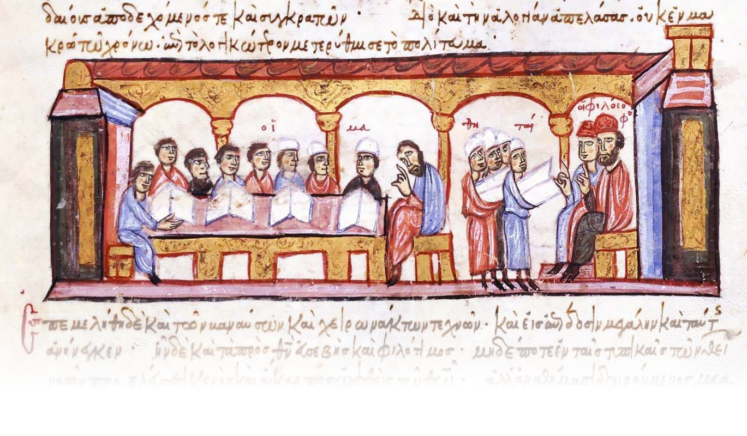
Colloquia Ceranea VII
8-10 May 2025

Application Form – Panel Submission

Please note:

The application form should be completed in English.
Papers should be presented in English. Other languages are acceptable too, provided that the speaker prepares an English handout (or multimedia presentation) outlining the main points of the talk.
The talk should last no longer than 20 minutes.
The moderator should lead a discussion on the talks. We suggest that moderators do not present at panels that they chair. If you do not recommend a moderator for your panel, we will select one of the conference participants or organizers to fulfil that role.
The organizer of a panel may also moderate or participate in it.
A panel should include minimum 3 participants. The talks should last around 20 minutes each. Since the sessions last 1 hour 45 minutes, we will divide panels with more than 4 participants into two sessions.
If any of participants is requesting a reduced fee, require assistance during the conference or have a special dietary requirement (we will provide lunch during the conference for those attending in person), please write below or ask him/her to contact the organisers directly.
Please sent the application by February 28, 2025 to the following e-mail address: colloquia.ceranea@uni.lodz.pl

PANEL TITLE:

Organizer
First name:
Last name:
Institution:
Academic title:
Country:
E-mail:
Telephone number (not obligatory):
Form of participation: online/in person
Additional information:

Moderator
First name:
Last name:
Institution:
Academic title:
Country:
E-mail:
Telephone number (not obligatory):
Form of participation: online/in person
Additional information:

PARTICIPANTS

Speaker 1
First name:
Last name:
Institution:
Academic title:
Country:
E-mail:
Telephone number (not obligatory):
Title of paper:
Language of paper:
Multimedia presentation: yes/no
Form of participation: online/in person
Additional information:

Speaker 2
First name:
Last name:
Institution:
Academic title:
Country:
E-mail:
Telephone number (not obligatory):
Title of paper:
Language of paper:
Multimedia presentation: yes/no
Form of participation: online/in person
Additional information:

Speaker 3
First name:
Last name:
Institution:
Academic title:
Country:
E-mail:
Telephone number (not obligatory):
Title of paper:
Language of paper:
Multimedia presentation: yes/no
Form of participation: online/in person
Additional information:

Speaker 4
First name:
Last name:
Institution:
Academic title:
Country:
E-mail:
Telephone number (not obligatory):
Title of paper:
Language of paper:
Multimedia presentation: yes/no
Form of participation: online/in person
Additional information:

Speaker 5
First name:
Last name:
Institution:
Academic title:
Country:
E-mail:
Telephone number (not obligatory):
Title of paper:
Language of paper:
Multimedia presentation: yes/no
Form of participation: online/in person
Additional information:

If you have more than 5 speakers in your panel, please add their data below following the given scheme or use two application forms.

PANEL DESCRIPTION (max. 300 words)

ABSTRACTS (max. 300 words each)

Speaker 1

Speaker 2

Speaker 3

Speaker 4

Speaker 5

